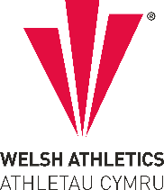
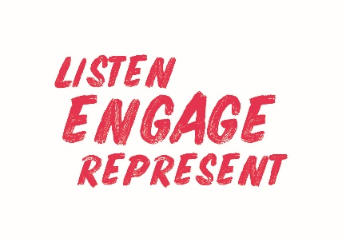

[Governance structure template minutes
Welsh Athletics Endurance Officials Meeting Minutes
Held on the Monday 6th February 2023
Meeting held remotely via video link

Present: Nigel Jones (Chair) Christine Vorres, Jacqueline Brace, Paul Brooks, Alex Donald.
Apologies: Zoe Holloway
Papers circulated in advance: Agenda, minutes of previous meeting in December.

Actions from meeting
Item Number | ACTIONS | Person responsible
7 | Alex to let Paul know if the Helena Tipping 10k is a championship event for Masters or only Seniors. | Alex

- Apologies for Absence – Zoe Holloway
- Declaration of Interest – None declared
3. Decisions
a) Matters arising from previous meeting:-
- Nigel has spoken to James regarding the 30p mileage allowance paid to officials as it has fallen so far behind what English Officials are receiving. This will now be put in writing to James
- Contact with Anne Phillips (trans gender Tutor) – ongoing
- Christine will email all level 1 officials to ask who needs a polo shirt, and to include Nigel.
- Governance Calender emailed out in December
- No concerns raised regarding Officials still awaiting their DBS to shadow at events.
- Insurance cover details have been sent out
- Discussion
Officials for the Schools Cross Country, sorted – Alex will be sending another email to them on Tuesday 7th to confirm. Officials for the Welsh Cross Country Championships have also been sorted and emailed.
Jacqueline will be responsible for maintaining a spreadsheet containing the details of any ‘banned athletes’
Regarding the incident of number swopping at the Snowdonia Marathon discussed at the last meeting, those athletes are not affiliated to any club and do not live in Wales – therefore there is no jurisdiction for Welsh Athletics to officially ban them from Welsh events. Alex advised that he has spoken with James Williams and James confirmed that Welsh Athletics will not be taking it further, but that the event organisers can themselves ban any athletes that do not adhere to the event terms and conditions.
Jacqueline also stated that a ban would be hard to police by Welsh Athletics.
Alex stated that James Williams is meeting with Jane Lloyd, the organiser of the Snowdonia Marathon tomorrow to talk about this matter.
Paul said that he feels the lack of affiliation and Welsh residency should not be an issue to banning athletes that break official event rules.
5. Correspondence
None
6. Regional Development Plan Update:
Not discussed.
7. AOB
Adjudicators:
Jacqueline told the meeting that there are now 2 new Adjudicators – Nigel agreed that they may shadow him.
Referee Forms:
Nigel asked Jacqueline where is the form that needs to be completed by the Referee for a Cross Country event – it is available to download on the website
https://www.welshathletics.org/en/page/licensing-an-event this should be completed and then sent to Jacqueline.
Alex confirmed that cross country events have Referees but not Adjudicators.
Inter-regional Championships
Alex confirmed the Helena Tipping 10k was agreed by all regions for hosting the championship. Paul asked if this was seniors only or included the Masters Champs – Alex will find out and report back.
First Aid Cover
Christine confirmed that she has met with the new Events Organiser at St Johns Ambulance and hoped that the situation regarding obtaining adequate cover at events is improving. Alex stated that he still has concerns as there have been issues in relation to the new online form to book cover. Specifically, no response being received after submitting the forms.
Officials Conference
Zoe to update the committee if anything arises in relation to the Conference.
7. Next meeting
Scheduled for 3rd April at the slightly later time of 6.30pm.

Minutes Written by
Christine Vorres
Secretary.
6th February 2023

